**[date]**

**Church Board Proposal**

I hereby put through a **request for approval** for the **expense** of $39/month for the use of eDisciples.com - a church management system.

eDisciples will supply us with an **all-inclusive church management system** and **app for our congregants.**

The app comes with the following features:

* **A free app for all church members** both on Android and iOS
* A **communication system** (send app messages, SMS, and emails from the system)
  + Send messages to certain groups of people (leaders, children’s ministry, etc), or;
  + Send messages to all members
* An **event management system** (members can RSVP to events)
* **Sermon playlists** (video and audio) - add your sermons so members can view it within the app
* **Church member management**
  + Manage salvations and personal details of each member of the church
  + Assign members to certain leaders
  + Automatic reminders for birthday and anniversaries
* **News system**
  + Send latest church news and allow members to “like” and comment
* **Roster + Task** Delegation System
  + Create and manage rosters for duties
  + Create and manage tasks for volunteers
* **Display bank details** and general church information
* An automatic, modern and beautiful **website** linked to the church management system
* **Online Giving** available as a bolt-on module

**Benefits:**

* You no longer need to manage your church via Whatsapp groups
* Member management no longer needs to be done via spreadsheets
* Church members can receive information timeously and effectively
* Leaders can coordinate their efforts via one system
* Events can be managed easily and effectively
* Communication can be handled via one central point
* New features are added every month - any suggestions from your side are welcome
* eDisciples is based in the United States of America and South Africa and has a dedicated support team should we need it. Simply call **+1 800-448-0427** (US) or 0861 003 125 (ZA) or email sales@edisciples.com

Your response on this matter would be highly appreciated.

Kind regards

**YOUR NAME**

___________________________________________________________

Example screenshots of the app in action:

**Church Leader Views:**

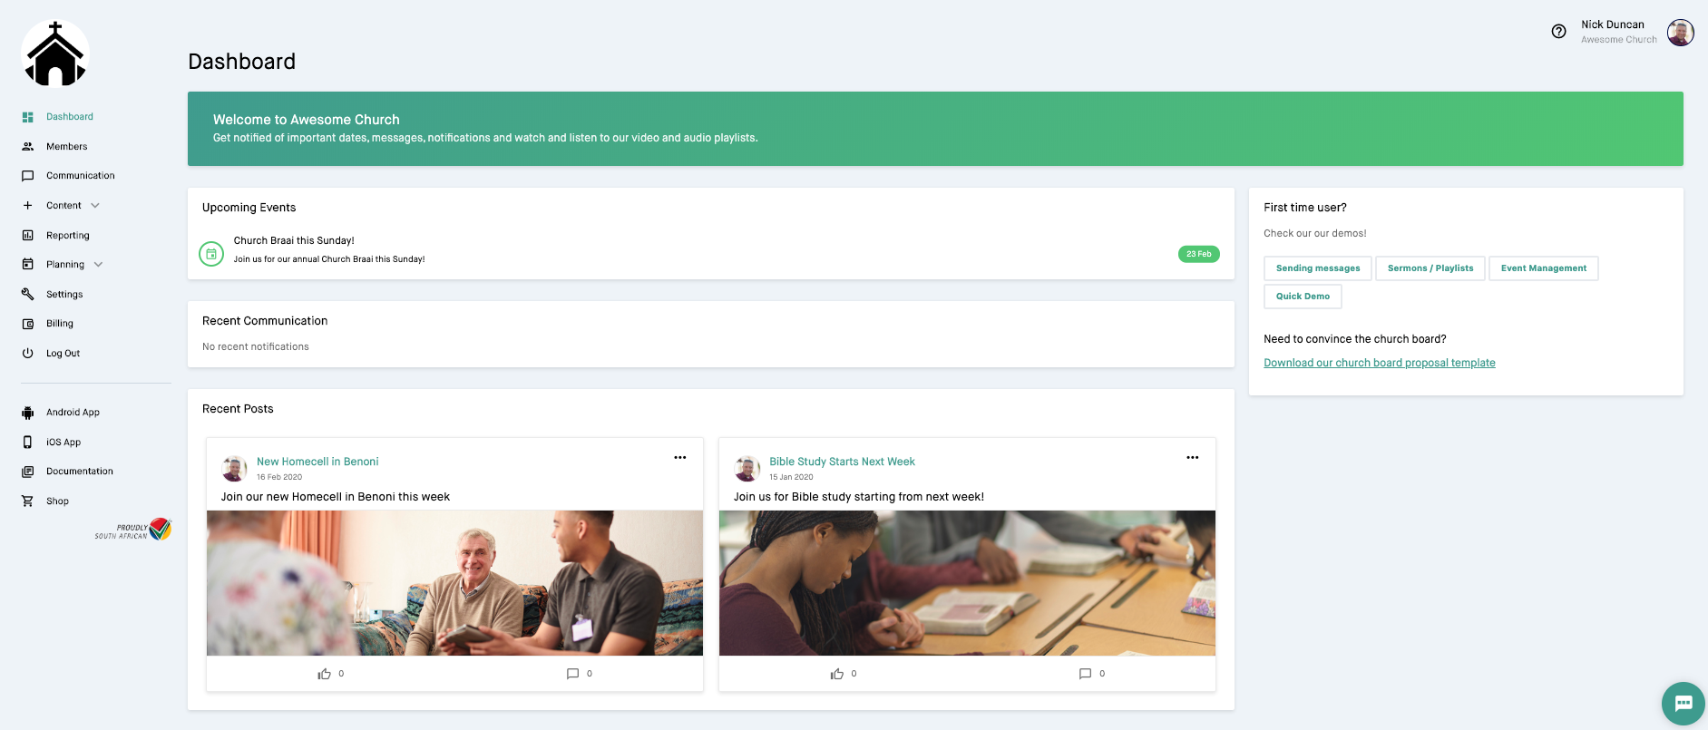

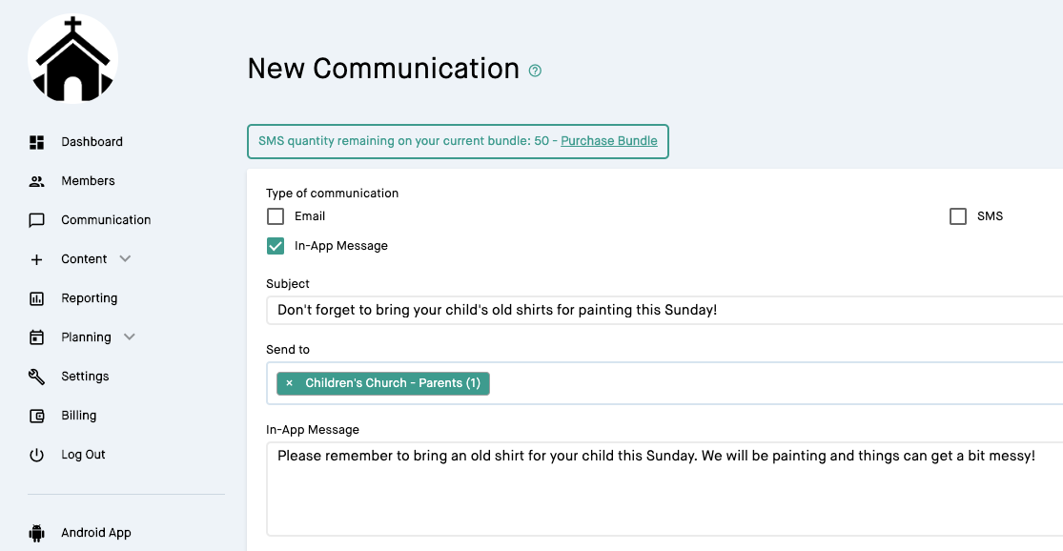

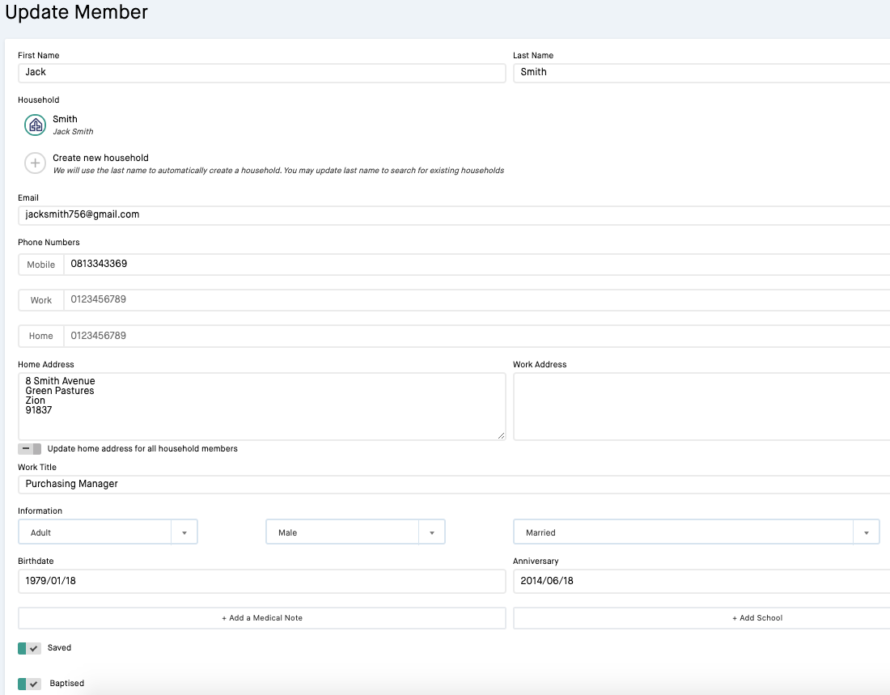

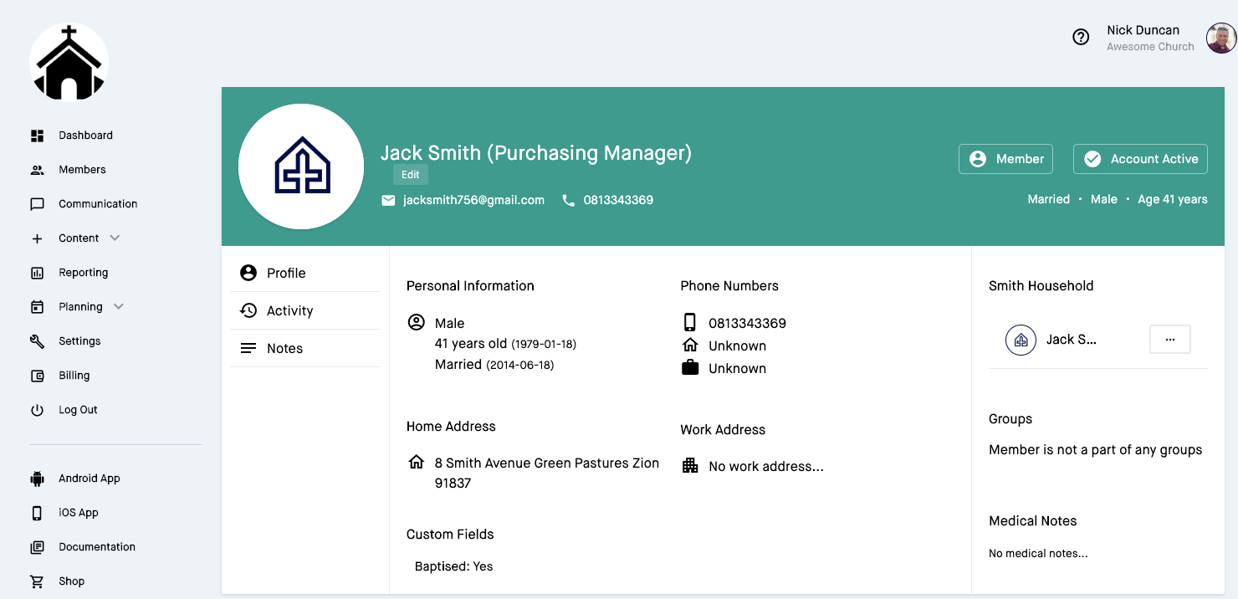

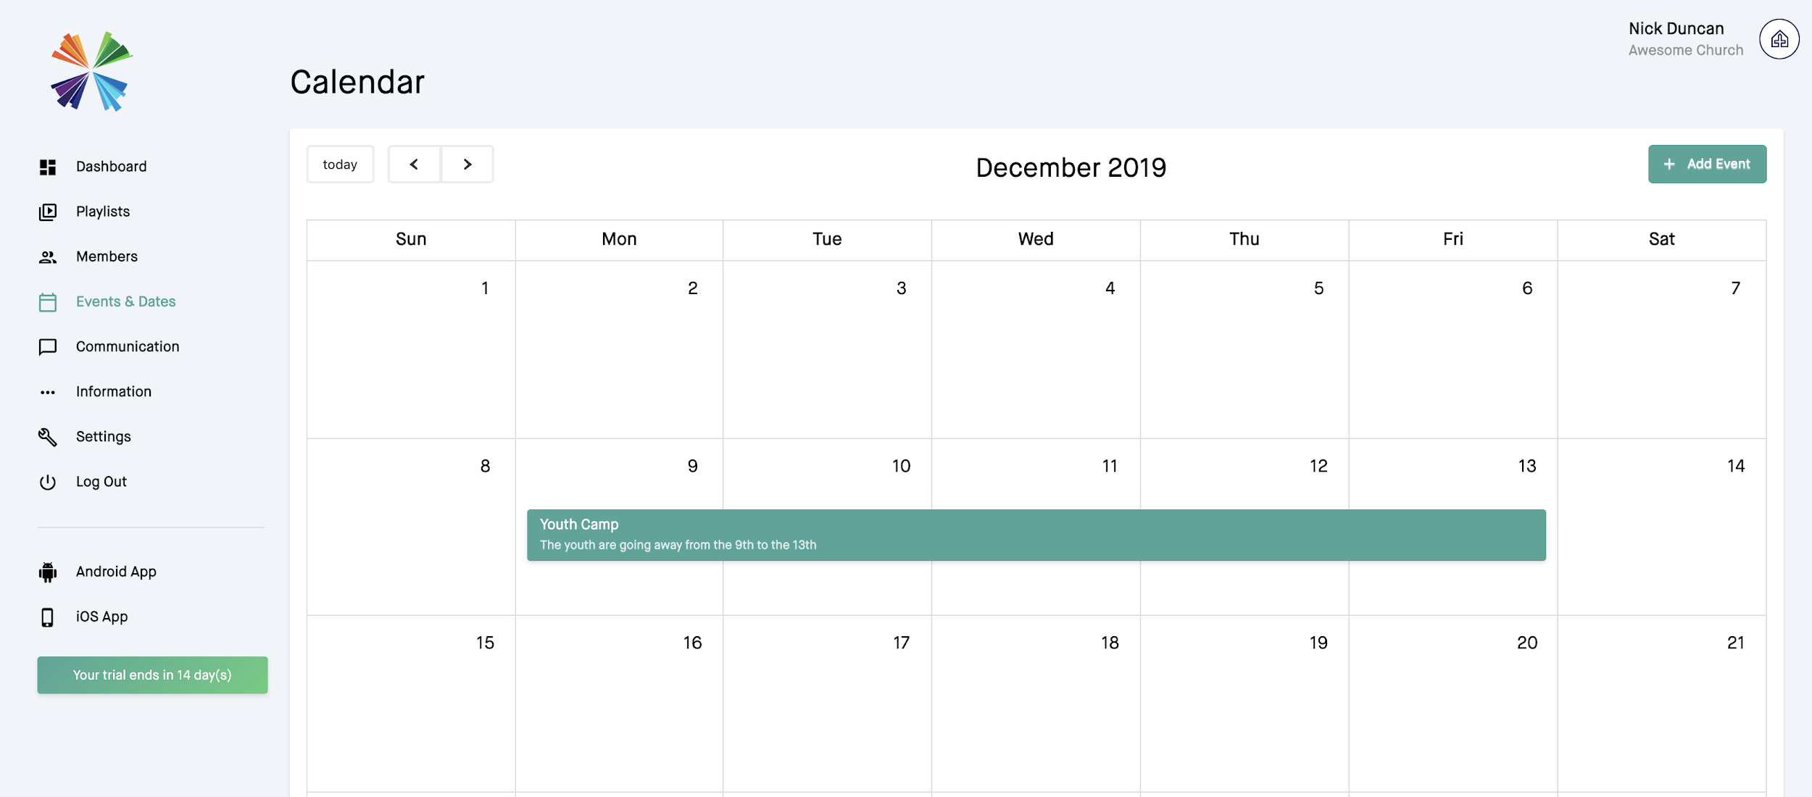

**Church Member View:**

